The CS system will upgrade in ChongQing province hospital. Team arranges this phase performance testing work to insure the system can works well in the site.

We execute the performance testing work on the actual hospital server and configuration as follow:

|  |  |  |  |  |  |  |  |  |  |  |  |
| --- | --- | --- | --- | --- | --- | --- | --- | --- | --- | --- | --- |
| **Server Name** | **Type** | **CPU** | | **Hard Disk** | | **RAM** | | **OS** | | **Required Software** | |
| CS Application Server | Ali-Cloud server | Intel Xeon(R) platinum 8136 CPU 2.50GHz *2 | 40GB | | 8G | | Windows 2016 data center | |  | |
| CS Database server | Ali-Cloud server | Intel Xeon(R) platinum 8136 CPU 2.50GHz *2 | 1T SATA Disk | | 8G | | Centos 7.4 x64 | | MySQL Server 5.7 | |

Team develops a mock service to simulate the WeChat platform service to make sure the CS workflow can works smoothly. QA develops a web service to get the result from database to subscribe the patients.

Before execute the performance testing, the CS has some history data and size as follow:

|  |  |  |
| --- | --- | --- |
| Table | Rows | Description |
| qrcodesceneinfo | 61826 | Store the register patient QR code |
| notificationmessage | 236470 | The message notify information to patient |
| filmreportstatus | 55753 | The patient film and report status |
| examreservation | 6040 | The patient exam reservation information. |

We design the performance testing scenario as follow:

1. Prepare 20 virtual users to simulate the patient typically workflow include register, query and message notify operations.
2. The virtual user will register in CS system, randomly create or update the film, report and reservation information and query the status.
3. Each virtual will wait for 3 seconds after it finish one workflow.
4. The scenario will execute for 12 hours.

During testing works, we do not find the hardware and software bottle neck issues in the CS application and database server. The CPU, memory and disk usage is very low.

The scenario executes for 8 hours and all virtual users are failed and error message as follow:

memory violation : Exception ACCESS_VIOLATION received. That`s an error cause by the test tool.

We need modify the test tool setting to restart the testing works.

Until the testing script stop works, the test result information as follow:

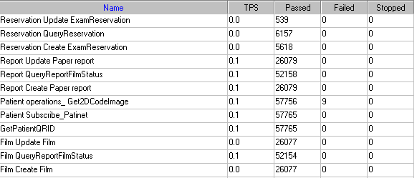

We can see the transactions passed and failed counts in the figure. There are 9 transactions of get2DCodeImage has failed because the network is not stability. The transaction response time is meets the requirements for our system.

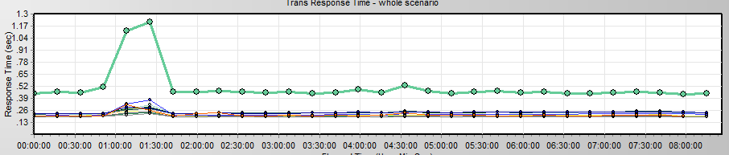

|  |  |  |  |  |  |  |
| --- | --- | --- | --- | --- | --- | --- |
| Color | Scale | Measurement | Minimum | Average | Maximum | Std. Deviation |
|  | 1 | Film Create Film | 0.204 | 0.238 | 9.438 | 0.127 |
|  | 1 | Film QueryReportFilmStatus | 0.178 | 0.198 | 5.223 | 0.061 |
|  | 1 | Film Update Film | 0.204 | 0.238 | 10.873 | 0.103 |
|  | 1 | GetPatientQRID | 0.190 | 0.223 | 16.454 | 0.266 |
|  | 1 | Patient operations_ Get2DCodeImage | 0.393 | 0.506 | 27.652 | 0.545 |
|  | 1 | Patient Subscribe_Patinet | 0.182 | 0.200 | 15.609 | 0.194 |
|  | 1 | Report Create Paper report | 0.205 | 0.238 | 13.804 | 0.128 |
|  | 1 | Report QueryReportFilmStatus | 0.178 | 0.199 | 13.545 | 0.110 |
|  | 1 | Report Update Paper report | 0.204 | 0.238 | 2.932 | 0.073 |
|  | 1 | Reservation Create ExamReservation | 0.192 | 0.210 | 1.366 | 0.062 |
|  | 1 | Reservation QueryReservation | 0.181 | 0.194 | 2.899 | 0.054 |
|  | 1 | Reservation Update ExamReservation | 0.192 | 0.213 | 0.990 | 0.072 |

Follow the result information, we can find the follow information as follow:

During the testing works:

1. There are 57765 patients registered to System by getting 2D code image from CS system.
2. There are 26079 reports were created and updated information, 52158 reports query information notify to patients.
3. There are 26077 films were created and updated information, 52154 query information notify to patients.
4. There are 5618 reservations were created, 539 reservations updated information, 6157 query information notify to patients.

From the actual site, there are 3,000 patients use our system every day. So follow the testing, we can ensure the system can work well for 19.2 days (57765/3000).

We found some performance issues after the testing works. There are some issues for database such as some SQL statements do not use the index and the configuration need enhanced.

I will execute the testing works on ali-cloudy machine again because the scenario stops with failure. The issues analysis and tuning suggestions will publish with the detail report after the next testing work finished.

Any questions please let me know.